PREQUALIFICATION QUESTIONNAIRE
Husky Ref. No.: |  |  |  |  |  | 8.37.2.069 | Goods/Services Title: |  | WHP Coiled Tubing Deployed Electric Submersible Pump
 |  | THIS QUESTIONNAIRE IS TO BE COMPLETED BY VENDORS WHO ARE INTERESTED IN SUPPLYING EQUIPMENT, MATERIALS AND/OR SERVICES TO HUSKY OIL OPERATIONS LIMITED. THE INFORMATION PROVIDED IS STRICTLY CONFIDENTIAL AND SOLELY FOR THE USE OF HUSKY.
COMPLETED QUESTIONNAIRE MUST BE MAILED OR COURIERED TO:
Husky Energy
351 Water Street
St. John’s, NL A1C 1C2
Attention: Valerie Antle
Category Manager, Offshore Drilling & Completions
Company Name:
The signatory of this Questionnaire guarantees the trust and accuracy of all responses given herein, and is an authorized officer or agent of the company.
Information submitted and completed by:
 |  |  | Name (Please Print)
 |  |  | Title
 |  |  | Signature
 |  |  | Date
To be completed by Husky:
Date Received: |  |  |  |  |  |  |  | Procurement Signoff:

Table of Contents

1. Company Information 3
2. Subcontracting 6
3. Work History 6
4. Current Organizational Structure 7
5. Facilities & Infrastructure 7
6. Capabilities Statement 7
7. Contractor HSEQ Requirements 8
8. Technical Requirements 23
9. Canada-Newfoundland and Labrador Benefits Compliance 24
10. Attachments 24
11. Additional Comments 25

General Instructions

We recognize that we have many different types of suppliers / contractors with different core competencies and skill sets. In order to effectively assess your company, we require that this Questionnaire be filled out as it applies to your firm.

Husky is committed to ensuring fairness in our vendor selection process. Prequalification will be based on your company meeting our expectations for the goods and / or services to be supplied.

Submission Requirements

Vendors must submit one (1) hard copy and one (1) electronic copy of all requested documentation in an envelope or package, which must be clearly marked with the Title and Reference number of the Services for which they would like to be considered.

Vendors are required to submit their pre-qualification response in the following format and in the exact order as shown:

- Company Information
- Subcontracting
- Work History
- Current Organizational Structure
- Facilities and Infrastructure
- Capabilities Statement
- Contractor HSEQ Requirements
- Technical Requirements
- Canada -Newfoundland and Labrador Benefits Compliance
- Attachments
- Additional Comments

1. Company Information

1.1 | Company Name:
 | Street/Mailing Address of Office completing this Questionnaire
 | City: |  |  |  | Province:
 | Postal Code:
 | Telephone: |  |  |  | Fax:
 | Key Company Sales Contact
 | Canadian Head Office:
 | Street/Mailing Address:
 | Local Office:
 | Street/Mailing Address:

1.2 | Type of Company
 | Sole Proprietor |  |  | Partnership
 | Corporation – Private |  |  | Corporation – Public
 | Other (please identify):

Please supply Certificate of Incorporation, and identify and attach as an Appendix. If private ownership, please also identify the Principle Shareholders below.

 | Name
 | City |  | Province/State
 | Name
 | City |  | Province/State
 | Name
 | City |  | Province/State
 | Name
 | City |  | Province/State

1.3 | Subsidiaries, Affiliates, etc. (indicate whether wholly-owned or percent controlled)

1.4 | Total Number of Employees by Geographical Location
 | Newfoundland and Labrador
 | Other Canadian Provinces
 | International

1.5 | Declaration of Business Relationship (Company Owner/Management)
 | In accordance with the approval policy of Husky, all Vendors shall, as a condition of supplying goods or services to Husky, make full disclosure of any existing business relationships with any Husky employee and/or contractor or immediate relatives. If the Vendor fails to disclose an interest and/or the interest is falsely or insufficiently reported, Husky reserved the right to terminate or cancel any agreement of any kind which may have been entered into with the Vendor.
 | Are you a relative or of do you have a relationship with any Husky employee that would cause any real or perceived conflicts of interest?
 | No
 | Yes |  | (please specify):

1.6 | Annual Revenue & Operating Income (CDN$ in each of the last five years):
 |  |  | Revenue |  | Operating Income
 | Year |  | $ |  | $
 | Year |  | $ |  | $
 | Year |  | $ |  | $
 | Year |  | $ |  | $
 | Year |  | $ |  | $

 | Do you have 3rd party certified financial statements available for the most recently completed fiscal year? | Yes |  | No

(If yes, please attach latest copy)

1.7 Joint Ventures

The following questions apply to Joint Ventures only;

- Please provide a copy of your organizational structure showing all members of the Joint Venture.

- Provide the following Joint Venture Details:
- A copy of the Joint Venture Agreement
- A statement of the share equity of each of the participants
- The lead participant within the Joint Venture
- Outline how the Joint Venture will be managed with regards to objectives
- How are the Key Business Objectives of each Participant reflected in the Joint Venture
- The share and nature of the work provided by each participant
- Arrangements for the transfer of systems/information technology
- How do the Participants envisage the Joint Venture developing in the future

- In the case of a Joint Venture, detail how Bidder will optimize/merge the different participants, organization, cultures to ensure the greatest benefits are realized for Company.

2. Subcontracting

2.1 Please list any associated work that you would typically subcontract to other vendor(s) providing the following information for each:
 | - Specific type of work being subcontracted:
 | - Company Name:
 | - City: |  |  |  |  | Province/State:
 | - Contact Name at above noted Company:
 | - Contact Phone Number for above:
2.2 Describe the process you have for selecting subcontractors: (Also see Husky’s expectations in this area for item 13 - Contracted Services and Materials – under Section 7, Contractor HSEQ Requirements)

3. Work History

Please provide a list of at least the top three (3) recent clients of your firm, with whom you have contracts for scopes of work similar to that covered by this pre-qualification process. Provide the following information for each:

- Contract Name/Owner:
CDN $ Value: |  |  |  |  | Date(s) of Contract Term:
Description (Contract Scope of Work. Please be specific):
Location:
Reference (Contact Name): |  |  |  |  |  | Telephone:

- Contract Name/Owner:
CDN $ Value: |  |  |  |  | Date(s) of Contract Term:
Description (Contract Scope of Work. Please be specific):
Location:
Reference (Contact Name): |  |  |  |  |  | Telephone:

- Contract Name/Owner:
CDN $ Value: |  |  |  |  | Date(s) of Contract Term:
Description (Contract Scope of Work. Please be specific):
Location:
Reference (Contact Name): |  |  |  |  |  | Telephone:

4. Current Organizational Structure

Please provide a current Organization Chart for your company, indicating, but not limited to, management personnel and reporting relationships. Please also identify where this organization’s management personnel are located. Please ensure the organization chart indicates personnel (including names) which would be supporting the scope of work. Please also identify where these individuals are located geographically.

5. Facilities & Infrastructure

Please provide a description of the facilities & infrastructure which your company would utilize in provision of the subject services, if applicable. Please clarify whether the facilities & infrastructure which you are describing are currently occupied and utilized by your company. Please provide photographs / drawings as appropriate.

6. Capabilities Statement

Please provide an overview of your company’s capabilities. In addition, please ensure that you provide a description of your company’s specific capabilities as they related to the subject services being requested.

7. Contractor HSEQ Requirements

READ CAREFULLY, ANSWER COMPLETELY AND
ENSURE SUPPORTING DOCUMENTATION IS PROVIDED WHERE REQUIRED

These pre-qualification questions are based on Husky's Contractor HSEQ Requirements. They are intended to establish the content and maturity of an organization’s HSEQ management system.

For any “Yes” answer provided, Husky requires a documented reference to a policy/procedure/standard and a copy of supporting documentation which can be referenced as evidence to validate any “Yes” answers. Any “Yes” answers not supported by documentation and appropriate references cannot be evaluated and may result in disqualification. All answers may be subject to further verification efforts by Husky.

Specific examples of the types of documentation such as procedures, samples of records etc. are described below each question as a suggested way of satisfying the required supporting evidence.

All submitted documentation must be packaged in such a way as to facilitate the ease of review and evaluation of the contents. This includes specific document page and or section references for each question in the order they are presented i.e. a Procedure to support an answer for question 5.8 must come after a procedure to support 2.6.

In many cases the same procedure or document may support multiple questions, please ensure the page or section reference is clear.

For Example:
Question 9.2. Does the change process clearly define change?

Response: YES Tab 9 Management of Change Procedure ABB-MOC-OPS-1234 Section 3.1 Page 4

In some cases a specific documented procedure may not exist to satisfy the question however a process may still exist. In such a case please provide a description of the process as it exists in your organization, these processes however will be subject to further verification as necessary.

Much of this HSEQ Questionnaire can be answered by submitting the following documentation. This checklist list is ONLY A GUIDE and is not meant to be comprehensive or exclusive of other relevant information your organization may be able to provide to support your answers.

If there are any questions please contact the Husky Procurement Representative.

Document Submission Checklist
Document | YES/NO
- HSE Manual
- Quality Manual
- HSEQ Policy(ies)
- Drug and Alcohol Policy
- New Employee Orientation and Induction Procedure(s)
- Risk Management Procedure(s)
- Emergency Response Plan
- Business Recovery/Continuity Plan
- Equipment Maintenance Program Manual
- Hazardous Areas Procedure(s)
- Training and Competency Procedure(s)
- Incident Management and Investigation Procedure(s)
- Environmental Protection and Management Procedure(s)
- Management of Change Procedure(s)
- Document Control Procedure(s)
- Confidential Information Procedure(s)
- Project Execution Procedure(s)
- Contractor Management Procedures
- Non-Conformance Procedure(s)
- Supplier/Contractor Evaluation Procedure(s)
- Materials Receiving Procedure(s)
- Audit Procedure(s)
- Lessons Learned Procedure(s)
SAMPLES OF:
- Annual HSEQ Performance Objectives, KPIs and current status
- Management Review Meeting Minutes
- Safety Meeting Minutes
- Safety Alerts or Bulletins
- Safety Observation Cards
- MSDS Register
- Risk Ranking Matrices
- Emergency Drill and/or Exercise Reports
- Job Descriptions for Management, Safety Critical Roles and those responsible for the Management System
- Hazardous Area Equipment Register
- Critical Equipment List
- Spare Parts for Critical Equipment Inventory List
- Failure Trends Analysis Report
- Maintenance System record for a critical system or piece of equipment
- Preventative Maintenance Backlog Statistics
- Sample of Calibration Record(s)
- Training Matrices
- Training Course Outline
- Incident Investigation Report
- Management of Change Form
- Internal and Supplier Audit Report
- Audit Schedule and current status
- Audit protocols or templates
- Corrective Action Management report and current status of all actions
- Purchasing/Contract Template
- Contractor Prequalification Questionnaire/Evaluation Form
- OHS Committee Meeting Minutes
- OHS Committee/WHSR Membership list and Terms of Reference

Provide HSE performance statistics for the last 3 years for the following information:
Statistics including Sub-Contractor data
ITEM | 20-- | 20-- | 20--
Fatalities
Lost Time Injuries
# of Lost time Days
Restricted Work Cases
# of Restricted Work Days
Medical Aids
First Aids
Near Misses
Total Exposure Hours
LOST TIME INJURY RATE
TOTAL RECORDABLE INJURY RATE
Motor Vehicle Accidents
Reportable Environmental Spills

Statistics for Proponent Alone
ITEM | 20-- | 20-- | 20--
Fatalities
Lost Time Injuries
# of Lost time Days
Restricted Work Cases
# of Restricted Work Days
Medical Aids
First Aids
Near Misses
Total Exposure Hours
LOST TIME INJURY RATE
TOTAL RECORDABLE INJURY RATE
Motor Vehicle Accidents
Reportable Environmental Spills
- Lost Time Injury Rate based on 200,000 person hours
- Total Recordable Injury Rate based on 200,000 person hours

1 | Leadership and Accountability | YES/NO | Tab # | Document Title | Document Number | Section and Page #
1.1 | Does the organization have an HSEQ Policy or policy statement?
1.2 | Does the organization have a formalized documented Management System
1.3 | Does the leadership actively and visibly participate in and promote the Management System?
1.4 | Does the organization participate in industry associations and other networking activities in order to integrate best practices?
1.5 | Are the roles, responsibilities and accountabilities within the management system known, accepted and exercised?
1.6 | Does Management communicate and encourage employee participation in the processes?
1.7 | Are clear goals and specific objectives for the management system established and is performance measured against these goals and objectives?
1.8 | Is there a regular management review of the HSEQ Management System and is this communicated to all employees and stakeholders?

2 | Safe Operations | YES/NO | Tab # | Document Title | Document Number | Section and Page #
2.1 | Is a comprehensive safety program implemented that includes programs for safe operations of tasks?
2.2 | Is there an OHS Committee and/or a worker health and safety representative, or workplace health and safety designate in place?
2.3 | Does the organization have a Drug and Alcohol Policy?
2.4 | Does your company have a hazard prevention program?
2.5 | Is there a program in place that includes requirements for human factors, ergonomic risk considerations, fatigue management, and workplace physical and mental demands are identified, analyzed and addressed?
2.6 | Is there an industrial hygiene and medical surveillance program?
2.7 | Is there a safe handling of chemicals and/or hazardous materials system?
2.8 | Is there an approved material substance register established that clearly defines those materials that are permitted to be used at any site? (By definition, the use of any substance not identified on this list shall be prohibited).
2.9 | Is a process implemented for identifying Personal Protective Equipment (PPE) requirements, ensuring that PPE is available and functional, and training in the use of PPE is conducted for employees?
2.10 | Are procedures implemented to ensure critical information to safe and efficient daily operations is effectively communicated to all levels of the company?
2.11 | Is a positive and open safety culture established where employees are educated, encouraged and expected to examine all tasks and work methods?

3 | Risk Assessment and Management | YES/NO | Tab # | Document Title | Document Number | Section and Page #
3.1 | Is there a documented risk assessment and management process or program?
3.2 | Are risk assessments conducted addressing risk to people, facilities and the environment?
3.3 | Are existing risk assessments reviewed at specific intervals?
3.4 | Are risk assessments performed by qualified personnel including, where appropriate, suitable expertise sought from outside the immediate business unit?
3.5 | Are risks prioritized to personnel, assets, the public and the environment?
3.6 | Is a follow up process in place to ensure that risk management decisions are implemented?

4 | Emergency Preparedness | YES/NO | Tab # | Document Title | Document Number | Section and Page #
4.1 | Does the organization have an emergency management system?
4.2 | Is the emergency management system based on specific hazards and risk assessments?
4.3 | Are the incident coordination and area emergency response plans integrated with relevant crisis management plans?
4.4 | Are incident coordination and area emergency response plans clearly communicated to all employees, contractors and stakeholders?
4.5 | Are simulations, drills or exercises conducted on a periodic basis?
4.6 | Are emergency preparedness and response plans reviewed periodically and updated?
4.7 | Are emergency response personnel trained and equipment and facilities maintained?
4.8 | Is a business recovery plan developed and implemented?
4.9 | Are operating partners and contractors included in the emergency response plans and is there joint cooperation with them?

5 | Reliability and Integrity | YES/NO | Tab# | Document Title | Document Number | Section and Page #
5.1 | Is there a process in place to establish and implement various operating, maintenance, monitoring, test, calibration, and inspection procedures?
5.2 | Is there a critical elements (equipment, systems, processes etc.) list?
5.3 | Are the inspection, calibration, maintenance and repair requirements associated with critical elements identified?
5.4 | Has a spare parts inventory been developed for critical equipment?
5.5 | Have specific procedures and programs been implemented to manage the hazards associated with equipment used in identified hazardous areas?
5.6 | Are failure trends tracked, reviewed and analysed to identify persistent problems?
5.7 | Are procedures implemented to manage the temporary disarming or deactivation and reactivation of critical equipment and devices?
5.8 | How is the maintenance schedule and frequency developed for inspection, maintenance and repair operations?
5.9 | Are critical tasks that require specific controls and competencies identified?
5.10 | Is there a process for reporting of deficiencies and tracking the actions to resolve them?
5.11 | Is there a procedure in place to describe how work performed on a piece of equipment is controlled and recorded?
5.12 | Is there a process implemented to plan, schedule and coordinate asset operations and work activities, for example shutdowns?
5.13 | Is there a process implemented to identify spare parts, support and test equipment for critical items and ensure they are available when needed?
5.14 | Is there a system to ensure materials/spare parts/equipment are available in inventory and a documented system to ensure the integrity of materials/spare/ parts/equipment is maintained?
5.15 | Is there a system implemented to monitor, report and manage maintenance, inspection, testing and monitoring backlogs against performance goals?

6 | Personnel Training and Competency | YES/NO | Tab # | Document Title | Document Number | Section and Page #
6.1 | Do job descriptions contain required competencies for all positions carrying out activities that may affect operational integrity?
6.2 | Does personnel recruitment, include fit for work assessments and pre-employment medicals, where appropriate?
6.3 | Is there a process for screening, selection, placement and ongoing assessment of the qualifications and abilities of personnel to meet specified job requirements?
6.4 | Is there initial, ongoing and periodic refresher training to meet job and regulatory requirements?
6.5 | Do in-house training sessions set out clear deliverables?
6.6 | Is there a competency assessment and management program?
6.7 | Are periodic reviews conducted to ensure appropriate staffing levels are maintained to assure safe and efficient operations?
6.8 | Do new or transferred employees undergo appropriate site orientation and induction training? (At a minimum it shall include HSEQ rules, management systems and emergency procedures).
6.9 | Does the organization monitor, measure and ensure policy, process and regulatory compliance of its workforce?

7 | Incident Management | YES/NO | Tab # | Document Title | Document Number | Section and Page #
7.1 | Is there an incident management system existing to ensure all HSEQ incidents are reported, and tracked?
7.2 | Is there a process to ensure that serious incidents and subsequent investigations are reported to clients such as Husky Energy?
7.3 | Are incidents categorized and investigated at a level appropriate for that categorization?
7.4 | Are incident investigations conducted using proven investigation techniques and are the results of the investigation documented?
7.5 | Is incident data analyzed and reviewed?
7.6 | Is there a system used to track preventative and corrective follow up actions?
7.7 | Are lessons learned and near misses communicated within the organization?
7.8 | Is there a process for the communication and distribution of internal and external safety alerts or bulletins?

8 | Environmental Management | YES/NO | Tab # | Document Title | Document Number | Section and Page #
8.1 | Are environmental management systems, established, implemented and monitored to address environmental impacts and demonstrate compliance with regulations?
8.2 | Are local site performance indicators and targets set to drive continual improvement in managing waste, emissions and discharges, and energy efficiency?

9 | Management of Change | YES/NO | Tab # | Document Title | Document Number | Section and Page #
9.1 | Is there a documented management of change process to consider all changes that directly affect facilities, assets and people?
9.2 | Does the process clearly define change?
9.3 | Does the process ensure the documentation and tracking of change requests?
9.4 | Does the process evaluate the health, safety, environmental and quality risks of proposed changes?
9.5 | Does the process consider requirements for personnel training?
9.6 | Does the process include management review and approval?
9.7 | Does the process consider both permanent and temporary changes?
9.8 | Does the process consider the requirements for the updating of documentation? (i.e.: drawings, plans, procedures, etc.)
9.9 | Is there a system in place to ensure that the original scope and duration of temporary changes are not exceeded without review and formal approval?
9.10 | Is there a process for effective communication of changes to the affected parties or individuals?

10 | Information, Documentation and Effective Communications | YES/NO | Tab # | Document Title | Document Number | Section and Page #
10.1 | Is there document management system to manage technical and other documentation?
10.2 | Is technical and management system documentation controlled to include peer review and management approval to manage creation and change?
10.3 | Is information on applicable laws and regulations, licenses, permits, codes, standards and practices accessible?
10.4 | Are employee health, medical, occupational exposure and training records maintained with appropriate confidentiality?

11 | Compliance Assurance and Regulatory Advocacy | YES/NO | Tab # | Document Title | Document Number | Section and Page #
11.1 | Is there a system in place to identify and ensure ongoing compliance with regulatory requirements and codes and is it documented as part of the management system?
11.2 | Is the operation regularly audited or reviewed to ensure regulatory and process compliance?
11.3 | Is there a process for reporting and managing deviations from regulatory or corporate requirements?
11.4 | Is there a process in place to identify, track and comment on proposed legislation, regulations and emerging policy issues?

12 | Design, Construction Commissioning, Operating and Decommissioning | YES/NO | Tab # | Document Title | Document Number | Section and Page #
12.1 | Is a project execution process used to incorporate health, safety, environment, loss prevention, and technical standards requirements?
12.2 | Are operability, maintainability, reliability and total life-cycle cost systematically considered in the planning, design and construction process? Is operations and maintenance expertise fully integrated early into the process at the design and project stage?
12.3 | Are approved health, safety, environment and loss prevention guidelines, design practices and standards, that meet or exceed applicable regulatory requirements, and encompass responsible requirements where regulations do not exist, fully utilized in the design, procurement and construction of all new or modified facilities?
12.4 | Are risk management practices implemented to ensure designs meet integrity objectives?
12.5 | Are human factor principles fully assessed and incorporated in the project?
12.6 | Are deviations from approved design practices and standards, or from the approved design permitted only after review and approval by the designated technical authority, and after the rationale for the decision is fully documented?
12.7 | Are quality assurance processes in place to ensure that facilities and materials specified, received and used meet specifications and that construction is in accordance with the applicable standards?
12.8 | Is a formal pre-startup review performed and documented on all new or modified facilities prior to operation to confirm that they meet all applicable technical and operational requirements?
12.9 | Is a process in place to ensure that any performance or integrity related issues identified during the course of commissioning, operating and decommissioning are captured, assessed and, where appropriate, resolved?

13 | Contracted Services and Materials | YES/NO | Tab # | Document Title | Document Number | Section and Page #
13.1 | Is there a supplier or contractor pre-qualification and selection process?
13.2 | Are scopes of services and deliverables, performance measures and standards, quality, customer and regulatory requirements as well as provision of trained and competent personnel clearly defined in the contract/purchase documentation?
13.3 | Is there a process to ensure that received materials and services are verified against requirements?
13.4 | Are interfaces with suppliers identified and managed?
13.5 | Are materials and services evaluated using a risk ranking process to identify potential risk and risk mitigation measures?
13.6 | Is there a process to identify non-conforming products and services and to prevent their release or inadvertent use?
13.7 | Is supplier/contractor performance monitored and audited?
13.8 | Does the organization maintain a preferred bidders list of existing pre-qualified suppliers/contractors?
13.9 | Does the organization have a process to manage and evaluate sole source sub-contractors?

14 | Performance Assessment and Continuous Improvement | YES/NO | Tab # | Document Title | Document Number | Section and Page #
14.1 | Are HSEQ performance indicators established and evaluated?
14.2 | Is there an internal audit process?
14.3 | Are operations regularly assessed to determine if HSEQ performance objectives are met?
14.4 | How are the audit program, specific scopes and frequency determined?
14.5 | Do audits follow established protocols and are they conducted by competent auditors, or audit teams, including expertise from outside the immediate unit?
14.6 | Are findings from audits recorded, discussed and agreed with the assessed party?
14.7 | Do audited parties develop documented action plans to address audit findings and are they tracked?
14.8 | Is the effectiveness of management system reviewed?
14.9 | Is there a preventive and corrective action process implemented addressing inspections, non-conformances, and customer feedback?

8. Technical Requirements

All respondents are asked to complete the questions below as part of your technical submission. Answers to these questions can be submitted as an attachment to the questionnaire. Respondents should note that all questions must be answered and appropriate documentation supplied.

No. | Question / Information Requested
1. | Please provide a detailed description of the shore based facilities (including service, storage, maintenance, and testing facilities) that will be used to support this service.
2. | Please provide details on ability to maintain, service and test tools and equipment both locally and at the well site.
3. | What is your company’s spare / contingency philosophy and proposed inventory plan?
4. | Please provide details on your company’s equipment preservation procedures.
6. | Please provide details on manufacturer’s assembly and testing procedures that will apply to this scope.
7. | It is desired to have equipment available in the St. John’s area, ready for mobilization offshore by 01 January 2017. Please provide your company’s capability to meet or exceed the timing of this schedule. Please provide applicable key milestone dates, such as engineering design review, equipment delivery, SIT in St. John’s area, and load-out.
8. | ESPs will be run in 7” 32# 13Cr95 tubing to a depth of approximately 3,000mMD. It is anticipated that 562 series systems will be required. Please provide detailed confirmation that your company can provide CT ESP equipment in wells of this completion design and achieve this setting depth.
9. | It is anticipated that the CT hanger will land in a horizontal tree. CT ESP vendor will be responsible for lower connectors, hanger feed-through, surface connectors and related components and services to provide electrical supply from the surface to the installed motor. Please provide your company’s preference for feed-through design and ability to work with wellhead, tree, and hanger vendors should a new feed-through design be required.
10. | Please provide your company’s present worldwide and Canadian installed ESP populations and corresponding run-life metrics (run-life, mean-time between failures, mean-time between pull, etc.) for each of the following; single motor systems, dual tandem motor systems, triple tandem motor systems. Please specifically highlight 562 series systems and coiled tubing deployed systems.
11. | Please provide assembly details (pump, motor, electrical cable, connectors, clamps, coiled tubing, CT hanger, etc) for 562 series systems.
12. | Please provide details on how electrical cable is supported in coiled tubing. How does vendor ensure cable will not be dropped downhole during deployment and termination? Does vendor have a slack cable management system?
13. | It is anticipated that ESP oil producers will be stimulated with proppant, prior to ESP installation. Please provide detailed experience with ESP performance in proppant stimulated wells with particular attention on pump design, material selection, run-life performance, start up and operation, debris tolerance, and key technical lessons learned.
14. | Please provide discussion relating to the proposed 7” 32# 13Cr95 tubing selection and 5.62” series ESP components with specific reference to maximum safe fluid velocities and material erosional wear.
15. | Please provide details regarding the isolation of the pump intake and discharge to prevent fluid recirculation.
16. | Please provide details and/or considerations regarding pump intake and discharge which can prevent solids from packing the annulus and potentially cause problems when pulling a ESP. Note: ESP oil producers will be stimulated utilizing proppant.
17. | Please confirm platform electrical supply (detailed in questionnaire Appendix) is adequate for optimal ESP operation.
18. | Please provide details on your proposed surface connector and power cable.
19. | Please confirm ESP can be successfully deployed based on the intervention deck height limitations (detailed in questionnaire Appendix). Provide comments with regard to operating within this restriction. Include procedures and documents demonstrating experience working within height and area restricted projects.
20. | Please confirm proposed equipment is suitable for anticipated service environment (see questionnaire Appendix). What is the design service life for each major component (eg. pump, motor, coiled tubing, connectors, etc.)?
21. | An enhanced quality plan will be required. Please provide a sample enhanced quality plan including acceptance requirements to be recorded and forwarded to the Company prior to shipment of any equipment.
22. | Please provide information regarding downhole gauges/ sensors used with CT ESP installations. Please consider project specific wellbore configuration (7” 32# 13Cr95) and 562 series equipment when commenting on downhole gauges. Please comment on the feasibility of a pump intake pressure sensor.
23. | Please state the specific standards, specifications, and testing used by your company when selecting coil tubing for CT deployed ESP systems.
24. | Please confirm proposed coiled tubing is suitable for anticipated service environment (see questionnaire Appendix). What is the basis of coiled tubing selection with respect to project specific service environment?
25. | Please provide surface rig-up details when running and retrieving a CT deployed ESP with specific reference to required well control equipment. What well control equipment (for example, CT BOP) would be supplied by ESP supplier?
26. | Please provide a complete tools list for handling, testing, installation, pulling, and fishing coil tubing deployed ESP systems as described in this document. This listing will include all contractor tooling required and recommended tooling and equipment normally provided by third party contractors to support equipment as described.
27. | Please provide detailed information supporting your company’s ability to conduct full mock up Site Integration Tests modeling the dimensional limits expected on board the platform.
28. | Provide your company’s estimated crew requirements for installation, commissioning, start-up, troubleshooting, and pulling of coil tubing deployed ESP systems.

9. Canada-Newfoundland and Labrador Benefits Compliance

Husky Energy strongly supports providing opportunities to Canadian and in particular Newfoundland and Labrador companies and individuals, on a commercially competitive basis. Pre-qualified companies will be required to complete a Canada/Newfoundland and Labrador Benefit Questionnaire. Will you comply with requirements of Husky Energy (or any governmental authority) with respect to benefits and with all applicable guidelines of Husky Energy?

 | Yes |  | No

10. Attachments

Please indicate all attachments:

No. | Attachment | Yes/No
1. | Certificate of Incorporation.
2. | Declaration of Residency.
3. | Certified 3rd Party Financial Statements.
4. | Facilities & Infrastructure photographs/drawings.
5. | Copy of Organization Chart (with names) for personnel supporting the contract scope of work.
6. | A written statement indicating that there are no outstanding HSE charges, stop work orders or regulatory violations against your company.
7. | A written statement indicating there are no outstanding non-conformances or audit action plans stemming from a Husky conducted Health, Safety, Environment and Quality supplier audit.
8. | Copy of the most recent customer satisfaction survey relating to customer perceptions and customer satisfaction.
9. | Is a Certificate of Clearance from the provincial Workplace Health, Safety and Compensation Commission (WHSCC) available upon request by Husky? (Note: The Workplace Health, Safety and Compensation Act requires all employers performing work in Newfoundland and Labrador to register with the Commission.  Source: http://www.whscc.nf.ca/employers/Emp_RegisteringYourBusiness.whscc.

11. Additional Comments

Sample Declaration of Residency

Vendor represents that * for Canadian Income tax purposes

** is a resident of Canada

is not a resident of Canada

Furthermore, we attach a Certificate of Incorporation and undertake to immediately inform Husky Oil Operations Limited of any future change in our company’s tax status.

Name:
Title:
Signature:
Date:

* (please include complete entity name)
** (please check as appropriate)

Appendix A – General Electrical Data (Platform Power Supply)

Primary Power Supply | Volts: | 13.8 kV
Primary Power Supply | Frequency: | 60 Hz
Primary Power Supply | Phase: | 3 phase
Power Supply Details | Total System kVA: | Up to 6200 kW available for ESP  (Approx 28 MW in total)
Power Supply Details | Power Generation: | TBA
Power Supply Details | Distribution Grid or On-Site: | On Site
Surface Power Supply  Medium Voltage Variable Speed Drive  (to be specified and procured outside the scope of this document) | Primary Volts: | 6.6 kV
 | Secondary Volts: | As required by ESP design specification
 | kVA: | Range from 600 to 1,300 kVA
 | Hz: | 60
Power Supply Details | % Impedence: |  | TBA
Power Supply Details | % Reactance: |  | TBA

Appendix B – Reservoir and Production Data

PRODUCTION CONDITIONS
STATIC BOTTOM HOLE PRESSURE: | 31,640 / 4589 | kPa / psi
BOTTOM HOLE FLOWING PRESSURE: | 10,000 / 1450 | kPa / psi - Target
PRODUCTION OR TEST FLOW RATE: | 2500 – 1,000  (15,700 – 6,290) | m3/d (BOPD)
WELLHEAD TEMPERATURE: | 100 – 113  (212 – 235) | ^{O} C / F
TUBING / WELLHEAD PRESSURE | 7,000 / 1,015 | kPa / psi
CASING PRESSURE | 19,000 assuming gas lift | KPa

FLUID PROPERTIES
INITIAL RESERVOIR PRESSURE: | 31,640 / 4589 @ 3120 TVDmss (3196 TVDmbrt) | kPa / psi
BUBBLE POINT PRESSURE: | 29,710 / 4309 @ 3120 TVDmss (3196 TVDmbrt) | kPa / psi
Liquid PRODUCTIVITY INDEX: | 0.10 | m3/kPa/d
RESERVOIR TEMPERATURE: | 115 / 239 | ^{O} C / F
ORIGINAL GOR | 120 / 674 | M³/M³ / SCF/BBL
OIL API GRAVITY: | 30 | ^{O} API
WATER SPECIFIC GRAVITY | 1.03 | Air = 1
GAS SPECIFIC GRAVITY | 0.764 | Air = 1
WATER CUT | 0 at start-up | % water
IMPURITIES | 0% H2S (200ppm design), 2% CO2, 0.5% N2

VISCOSITY DATA
POINT | PRESSURE | TEMPERATURE | VISCOSITY | SATURATED GAS OR DEAD OIL
1 | 90 kPa / 13 psi | 113.7 deg C / 237 F | 2.23 cp | 0 m3/m3 GOR
2 | 12,500 kPa / 1813 psi | 113.7 deg C / 237 F | 0.94 cp | 48.7 m3/m3 GOR
3 | 29,710 kPa / 4309 psi | 113.7 deg C / 237 F | 0.59 cp | 118.1 m3/m3 GOR

PROPOSED OPERATING CONDITIONS
DESIRED PRODUCTION RATES | 1500 m3/d @ 0% W.C | TOTAL RATE - BFPD
DESIRED PRODUCTION RATES | 1900 m3/d @ 90@ W.C | TOTAL RATE - BOPD
DESIRED PUMP (INTAKE) SETTING DEPTH | 3000 mMDbrt
DESIRED PUMP INTAKE PRESSURE | TARGET is 10,000 kPa / 1450 psi Flowing Bottom Hole Pressure at top perforations. Note, at setting depth intake pressure of approximately 5500 kPa / 798 psi at 3500 mMDbrt.

PVT DATA
SOLUTION GOR | 0 m3/m3 FVF | 90 kPa / 13 psi
SOLUTION GOR | 48.7 m3/m3 FVF | 12,500 kPa / 1,813 psi
SOLUTION GOR | 118.1 m3/m3 FVF | 29,710 kPa / 4,309 psi
TEMPERATURE FOR PVT | 113.7 ^{O} C / 237 F

SPECIAL COMMENTS
Known Problems | Yes | No | Remarks
SAND | 1 lbs / 1000 bbls Design |  | Ceramic Proppant may be a concern in West Production wells. Proppant base case spec is CarboLite 16/20, Median particle size: 1000 micron (1 mm).
SCALE | CaCO₃ Expected |  | Scaling Study performed at surface and downhole conditions; CaCO₃ Scaling Tendency High (100 mg/l if untreated), FeCO₃ Scaling Tendency Medium (10 mg/l if untreated), BaSO₄ Scaling Tendency Low (0 mg/l)
PARAFFIN |  | None Expected
CORROSION |  | Mild

Appendix C – Proposed Completion Schematic

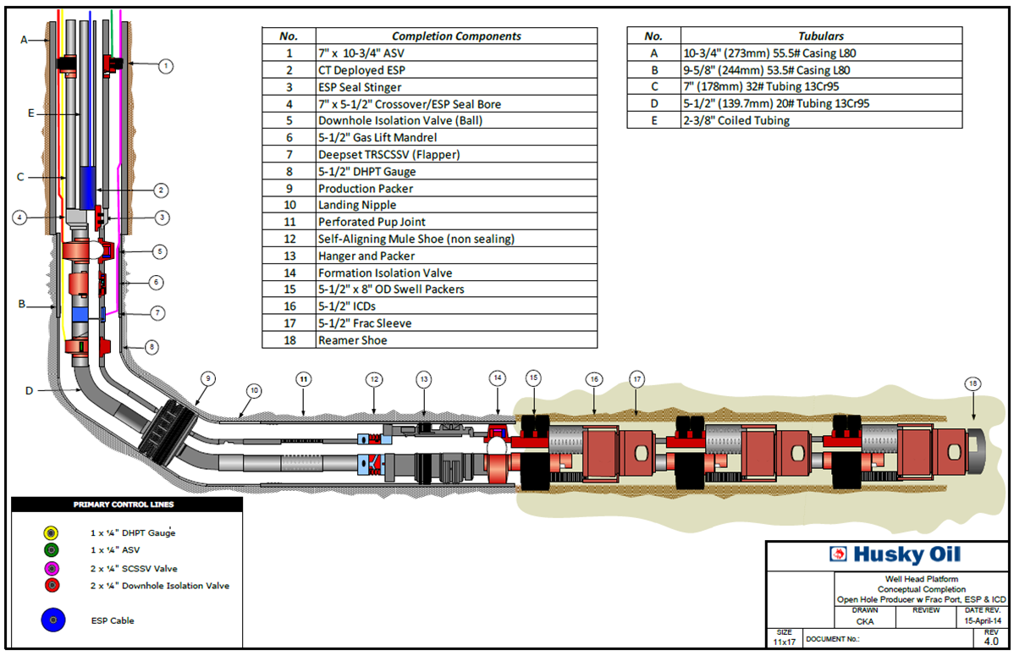

Appendix D – Proposed ESP Configuration

7” (178mm) 32# 13Cr95 Tubing
2-3/8” (60mm) Coiled Tubing
5-1/2” (140mm) 20# 13Cr95 Tubing
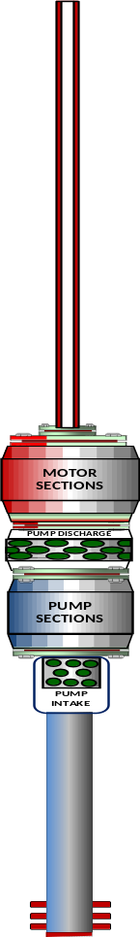

Appendix E – Proposed Wellhead and Horizontal Tree Configuration

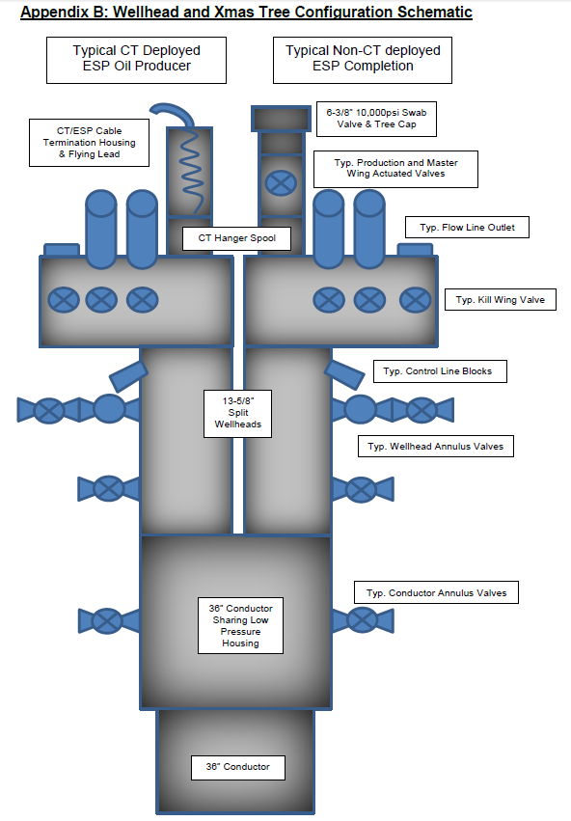

Appendix F – Intervention Deck Height Limitations

There are space limitations expected that may complicate installation and workover service handling on the platform. The expected vertical limit will be 11.0 meters. ESP equipment will need to be handled, dressed for installation, laid down, and accommodated within the restricted space. The major dimension limitation is due cranes running overhead. Final design and selection of these cranes is ongoing.

The worst case limits presently expressed by these cranes are:
- Top hook to middle deck top of steel = ~8.6m
- Distance between middle deck top of steel and below gantry crane beam = ~9.7m

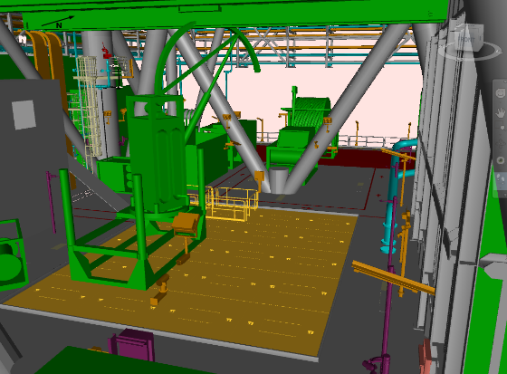
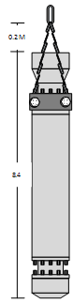

Intervention Deck

